THE PROPHECY
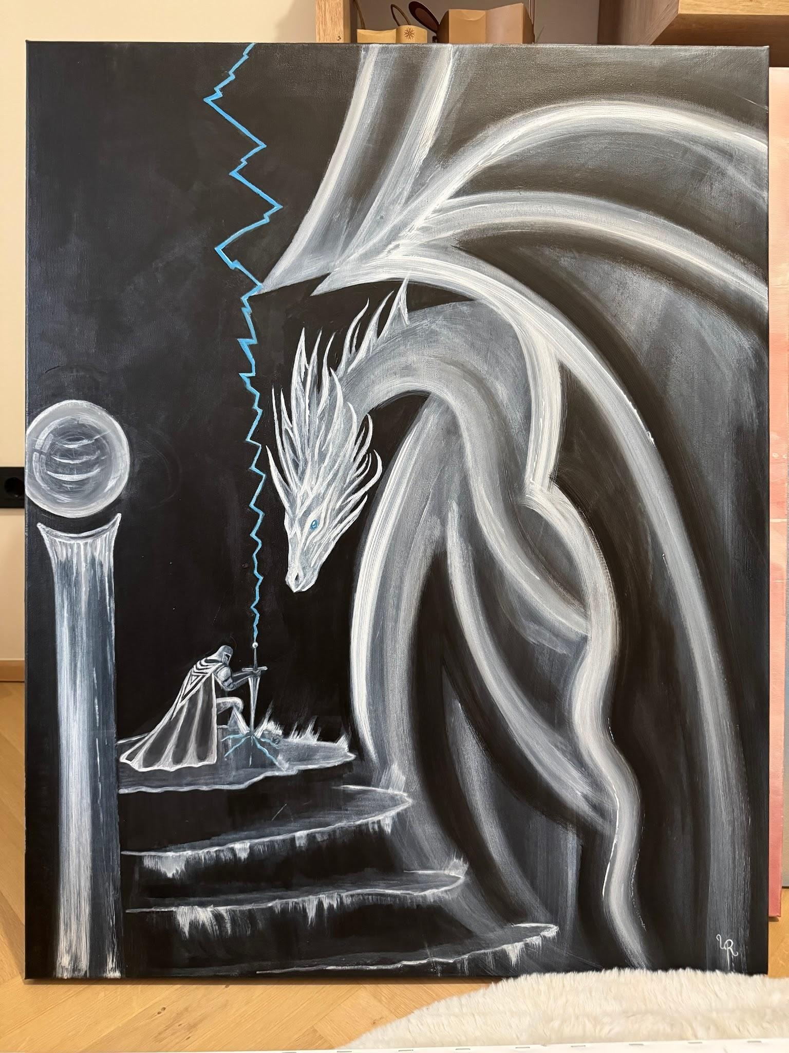

When darkness consumes the land,
the final knight shall rise.

With lightning tearing through the sky,
he will face the shadows without fear.

His sword shall burn with light,
his heart with courage.

For darkness may be ancient,
but bravery is stronger.

And when the knight stands against the night,
the light shall rise with him—
and the prophecy shall end.

